 | Remedy Acknowledge  System  1.0
 | Prepared By / Last Updated By | Reviewed By | Approved By
Name
Role | Team Member | Team Member | Scrum Master
Signature
Date

Table of Contents

1.0 Introduction 3
1.1 Purpose of this document 3
1.2 Scope 3
1.3 Intended Audience 3
1.4 Definition & Acronyms 3
2.0 Conventions and Standards Followed 4
3.0 Assumptions, Dependencies and Risks 4
3.1 Assumptions: 4
3.2 Dependencies: 4
4.0 Schematic Diagram 4
5.0 Use Case Realization 5
5.1.1 User Registration 5
a. Functional Requirement 6
b. UI Validations 6
c. UI Controls 7
d. UI Methods Definition 8
e. UI Design 9
6.0 Database Design 10
6.1 Data Model 10
6.2 Tables Structure 10
7.0 Change Log 13

Introduction

Purpose of this document
The purpose of the detail design document is to define the detailed design for all the components Remedy Acknowledgement system which make sure to add your remedy and tracking and getting done with that.

Scope
This sub-section shall state the scope of this detailed design document
• Create and maintain Remedy Management.

Intended Audience
The intended audience for this document are
- Developers, testers, other associates in the project
- Technical lead, Scrum Master

Assumptions, Dependencies and Risks

Assumptions:
- Once the application is built the REMEDY ACKNOWLEDGEMENT PORTAL will load the user issues into the system.
- There will be no concurrent users for the application. The Remedy issues will be maintained by the User.
- Any changes to the design mentioned in the BRD would be taken as a Change Request

Dependencies:
- Availability of database design characteristics & access shall be defined by the
- Resource availability throughout of some sprints.

The above pic is only an example and not representational of the Patient Health project

Use Case Realization

User Registration and Login
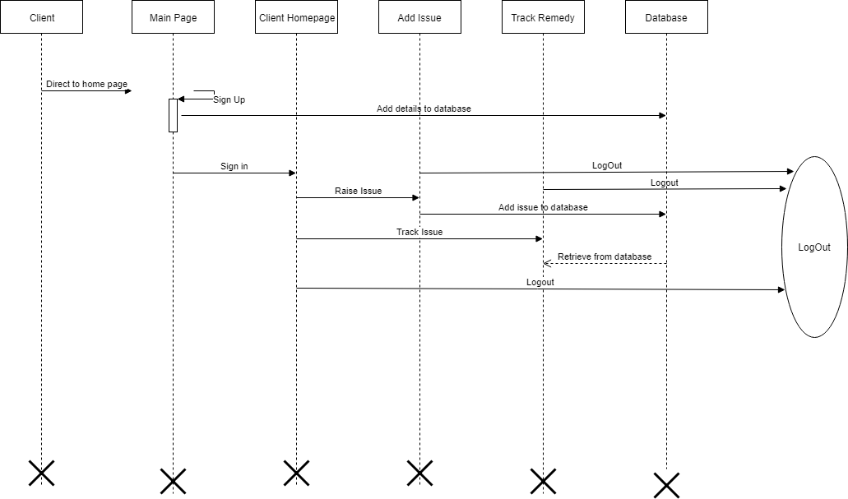

Functional Requirement
. Login Page checks the authentication of the user and based on his role, directs the user to the respective page. User will provided with Add Patient, Details, Regulation and Search regulation pages and the same user will allowed to see Diagnosis Reports and patient vital parameters reports

UI Validations
- User Id and Password fields are mandatory.
- Invalid User Id and / or password should not allow the user to get into the system

UI Design

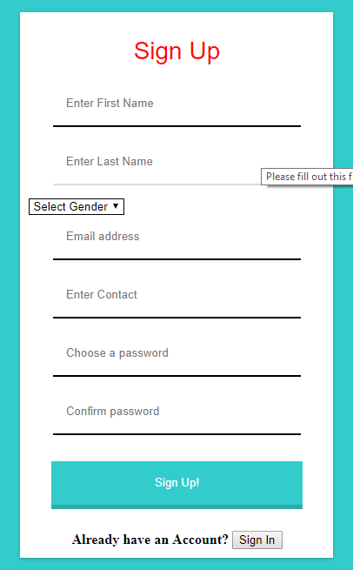

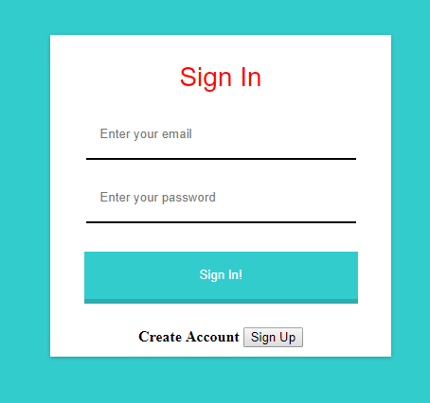

User Adding Issue and Tracking

Functional Requirement
. Add issue page must make user to add their issue by entering ticket id and issue and description and user can track their added issue by entering their appropriate email and check the status of the remedy.

UI Validations
- All Fields are mandatory.
- Invalid Email should not allow the user to get into the tracking system.

UI Design

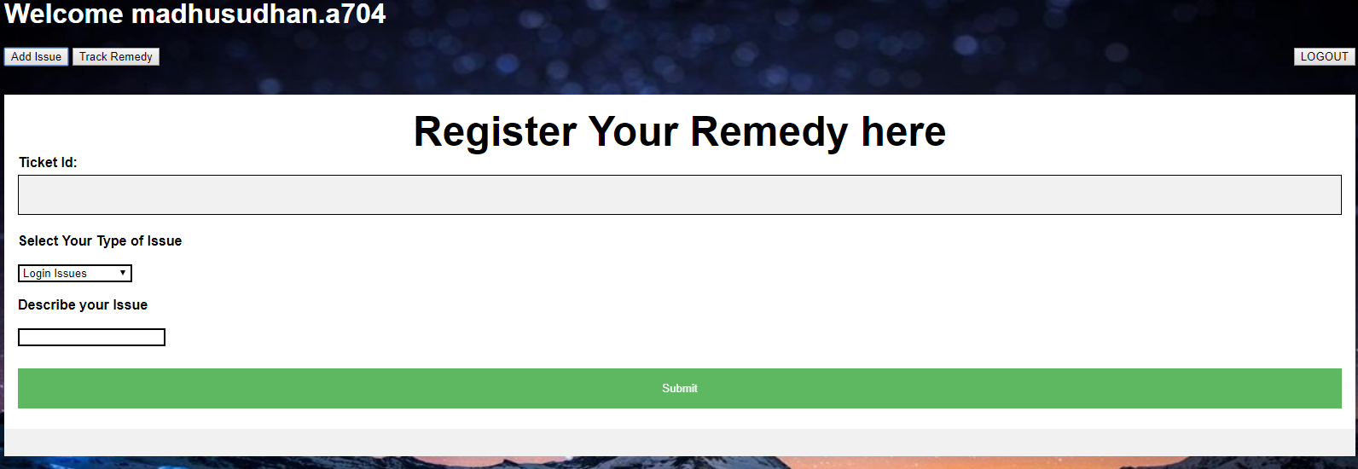
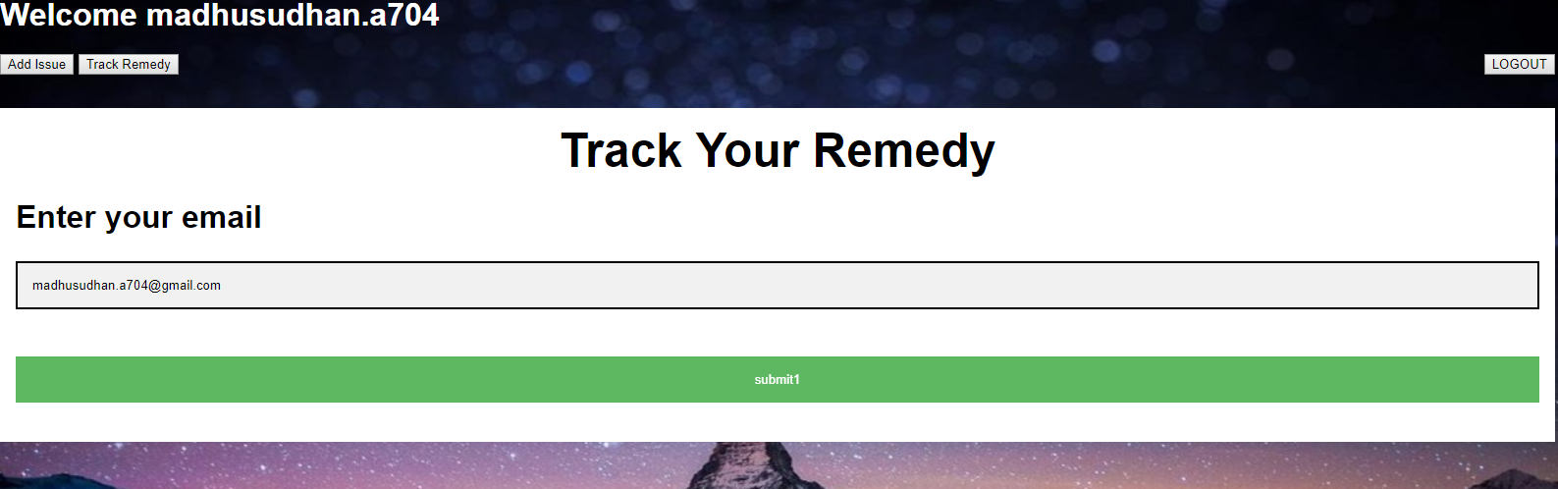

Admin Login & Remedy Management
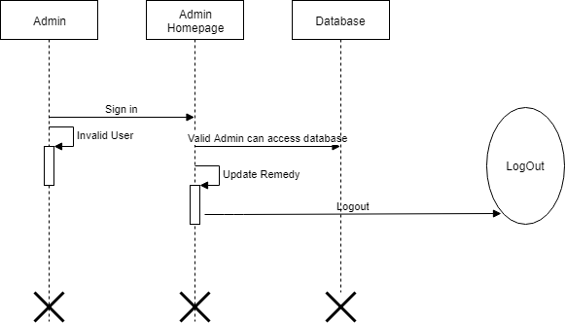

Functional Requirement
. As an Admin there will be no need of Registration and we proceed with Login directly and by validating the admin details like username and password it redirected to Admin Home page where we display all issues of clients/users so that admin can make sure to update the status of the remedy issue.

UI Validations
- User Name and Password fields are mandatory and must validated.
- Invalid User Id and / or password should not allow the admin to get into the system
- Provide Individual Update button for each issue so that no need of manual updation.

UI Design
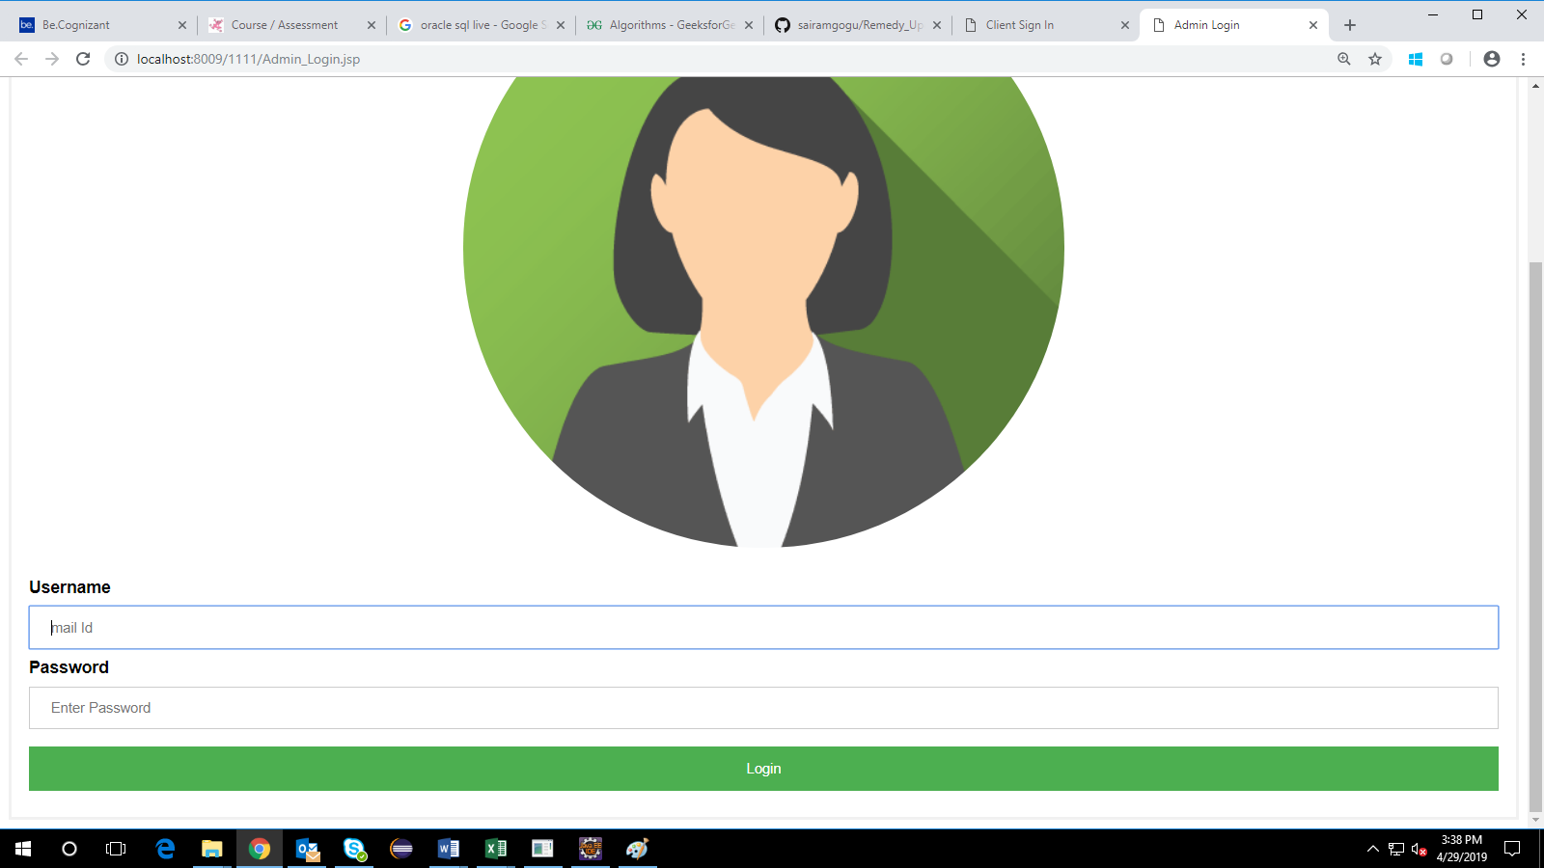

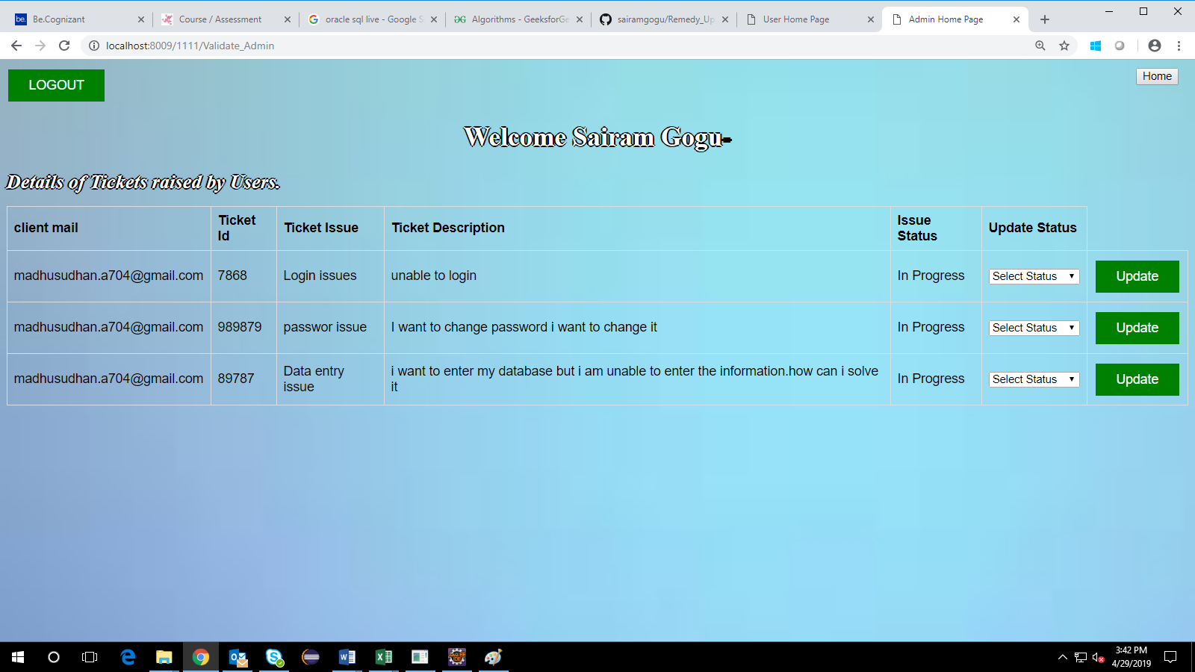

Database Description

Tables Structure
User Registration:
Column Name | Data Type | Length | Nulls
First Name | Varchar | 100 | NULL
Last Name | Varchar | 100 | NULL
Gender | Varchar | 10 | NULL
Contact | Varchar | 100 | NULL
Email | Varchar | 100 | PRI
Password | Varchar | 100 | NULL

Issue Registration:
Column Name | Data Type | Length | Nulls
Email | Varchar | 100 | NULL
Ticket Id | Varchar | 10 | NULL
Issue | Varchar | 100 | NULL
Description | Varchar | 1000 | NULL
Status | Varchar | 100 | NULL

Change Log
Please note that this table needs to be maintained even if a Configuration Management tool is used.
Version Number | Changes made
V1.0 | <First version>
V1.1 | <If the change details are not explicitly documented in the table below, reference should be provided here>
V1.1 | Page no | Changed by | Effective date | Changes effected
V1.2 | <If the change details are not explicitly documented in the table below, reference should be provided here>
V1.2 | Page no | Changed by | Effective date | Changes effected

